ECA0801
ANALOG AND DIGITAL COMMUNICATION
CO1 DESIGN TASK ASSIGNMENT
AM-Based Communication Link Design:
From Modulation Selection to Receiver Deployment
Submitted by
Lokesh A
Register Number: 192512293
B.E. Electronics and Communication Engineering (ECE)
Course Code: ECA0801
Subject: Analog and Digital Communication

REPORT STRUCTURE
- Executive Summary and Design Specifications
- Stage 1 – Communication Design Requirement
- Stage 2 – Modulation Scheme Selection
- Stage 3 – RF Channel Allocation and Transmitter Design
- Stage 4 – AM Receiver Architecture
- Stage 5 – Complete-System Development and Verification
- Stage 6 – Critical Evaluation and Deployment Decision
- Final Specification Verification

EXECUTIVE SUMMARY
This report designs a low-power educational analog communication link to carry a voice signal with a maximum message frequency of 4 kHz from a studio to a remote receiver. The given RF band is 540–1600 kHz, the candidate carrier is 1 MHz, channel spacing is 20 kHz, the conventional-AM modulation index is 0.7, and carrier power is 10 W. The channel includes additive white Gaussian noise (AWGN) and practical receiver limitations.
Conventional AM, DSB-SC, SSB-SC and VSB-SC are compared. Conventional AM is selected for the primary educational voice link because its receiver can use simple envelope detection and has low complexity. SSB-SC is a more bandwidth- and power-efficient alternative if coherent detection and more complex generation are acceptable. VSB is most appropriate in the assignment's comparison for analog television. A superheterodyne receiver with an illustrative 455 kHz IF is selected for stable selectivity and gain.
Parameter | Requirement | Design interpretation
Message signal | Voice/audio, f_m(max) = 4 kHz | Message bandwidth = 4 kHz
RF band | 540–1600 kHz | Total span = 1060 kHz
Candidate carrier | 1 MHz | Selected carrier
Channel spacing | 20 kHz | Nominal allocation grid
AM modulation index | 0.7 | 70%, below overmodulation
Carrier power | 10 W | Used in ideal AM calculations
Channel condition | AWGN/noise | Filtering and suitable detection required
Implementation | Low-power educational prototype | Real radiated power must follow lab and regulatory limits

STAGE 1 – INTERPRET THE COMMUNICATION DESIGN REQUIREMENT
Stage 1 is worth 10 marks. It asks for a basic communication block diagram, the need for modulation, bandwidth calculations, RF planning, ideal channel count, AM power, receiver requirements, and prototype constraints.

1.1 Basic communication-system block diagram
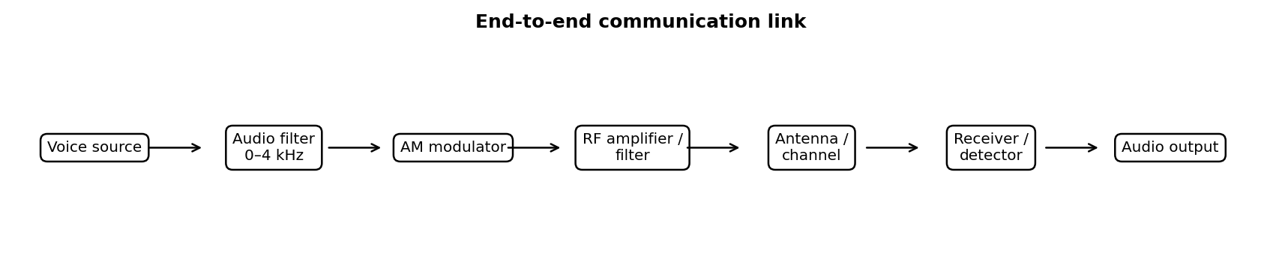
Figure 1. End-to-end communication link.
The voice source produces the information signal. Audio conditioning limits it to 4 kHz. The modulator combines the message with a radio-frequency carrier. An RF amplifier and output filter feed the antenna. The receiver selects and processes the desired signal, detects the message, and amplifies the recovered audio for listening.

1.2 Need for modulation
- Practical antenna size: low-frequency audio has a very long wavelength, making efficient direct radiation impractical.
- Efficient radiation and useful range: moving information to RF permits practical antennas and RF transmission.
- Station separation: separate carrier frequencies allow a receiver to tune to one station and reject others.
- Spectrum sharing: modulation allows multiple stations to occupy different RF channels.
- Direct baseband limitations: inefficient radiation, interference, and difficulty separating multiple simultaneous sources.

1.3 Message and transmission bandwidth
The maximum message frequency is f_m = 4 kHz, so the low-pass message bandwidth is B_m = 4 kHz.
Scheme | Theoretical bandwidth | Reason
Conventional AM | 2f_m = 8 kHz | Two sidebands plus transmitted carrier
DSB-SC | 2f_m = 8 kHz | Two sidebands; carrier suppressed
SSB-SC | f_m = 4 kHz | Only one sideband transmitted
VSB-SC | Approximately f_m + vestige width | One full sideband plus a controlled vestige

At f_c = 1000 kHz, conventional AM sidebands extend from 996 kHz to 1004 kHz, so the theoretical occupied bandwidth is 8 kHz.

1.4 RF channel planning and ideal channel count
The RF span is 1600 − 540 = 1060 kHz. Dividing by 20 kHz spacing gives 1060/20 = 53 intervals. If a channel centre is placed at each endpoint-inclusive grid position starting at 540 kHz and stepping by 20 kHz, there are floor(1060/20)+1 = 54 grid points. Thus, 53 is the number of 20 kHz intervals and 54 is the number of possible grid positions under that endpoint convention. Practical guard bands, licensing and emission limits can reduce the usable number.
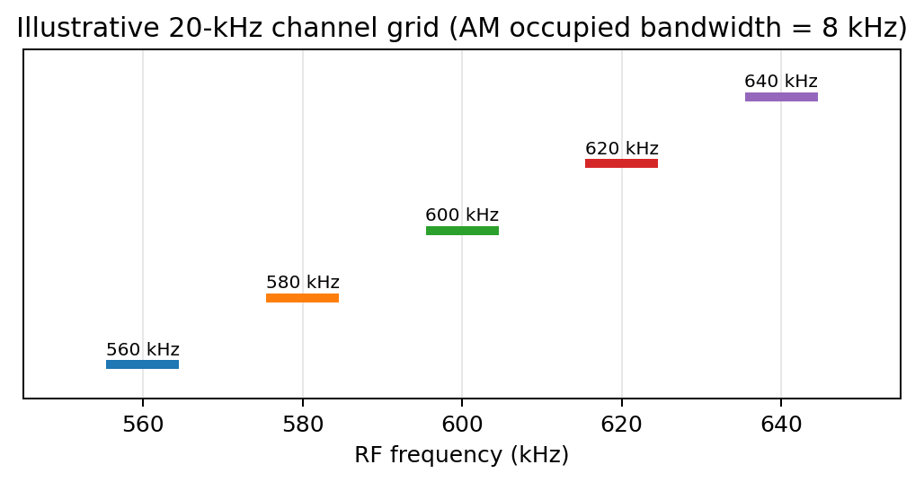
Figure 2. Illustrative five-channel plan; frequencies are examples, not a claim of licensed allocations.
An 8 kHz AM signal in a nominal 20 kHz channel spacing leaves 20 − 8 = 12 kHz between ideal occupied bands. Real filter skirts, frequency drift and emission rules must still be considered.

1.5 AM power calculation
For single-tone conventional AM, P_T = P_c(1 + m²/2). With P_c = 10 W and m = 0.7: P_T = 10[1 + (0.7²/2)] = 10(1.245) = 12.45 W.
Total sideband power is P_SB = P_c m²/2 = 10 × 0.49/2 = 2.45 W. Each sideband has half of this power: P_USB = P_LSB = 1.225 W.
Quantity | Formula | Result
Carrier power | P_c | 10 W
Modulation index | m | 0.7
Upper sideband power | P_c m²/4 | 1.225 W
Lower sideband power | P_c m²/4 | 1.225 W
Total sideband power | P_c m²/2 | 2.45 W
Total AM power | P_c(1+m²/2) | 12.45 W
Carrier share | 10/12.45 × 100 | 80.32%
Sideband share | 2.45/12.45 × 100 | 19.68%

These values use the standard single-tone AM model requested by the given modulation index. Actual speech contains multiple frequency components, so its detailed sideband-power distribution depends on the message.

1.6 Receiver requirements
Parameter | Requirement
Sensitivity | Receive a weak signal and still produce acceptable audio.
Selectivity | Reject adjacent-channel signals using tuned RF/IF filters.
Fidelity | Recover the voice spectrum up to 4 kHz without excessive distortion.
Stability | Keep the local oscillator and tuning stable.
Image rejection | Suppress unwanted signals that convert to the same IF.
IF considerations | Choose a practical IF that supports filtering and manageable image rejection.
Detection | Envelope detection for AM; coherent detection for DSB-SC/SSB-SC.

1.7 Prototype constraints and Stage 1 deliverable
- Use a permitted low-power setup, dummy load or shielded test arrangement as appropriate.
- Check impedance matching, output filtering, carrier stability, supply limits and modulation depth.
- The stated 10 W is a calculation parameter, not automatic permission to radiate 10 W.
- Document measured deviations from ideal calculations and simulated results.
Requirement statement: The system must transmit a 0–4 kHz voice signal using a carrier in the 540–1600 kHz band, with 1 MHz selected as the candidate carrier. Conventional AM has an 8 kHz theoretical bandwidth and a calculated total power of 12.45 W for P_c = 10 W and m = 0.7. The receiver must provide sensitivity, selectivity, fidelity, stability and image rejection while the channel plan respects 20 kHz nominal spacing and applicable regulations.

STAGE 2 – INVESTIGATE AND SELECT THE MODULATION SCHEME
Stage 2 is worth 20 marks. It requires expressions, bandwidth and power comparisons, power-efficiency reasoning, VSB television relevance, and a quantitative design decision.

2.1 Time-domain expressions
Let m(t) = A_m cos(2πf_m t) be a single-tone message and c(t) = A_c cos(2πf_c t) be the carrier.

Conventional AM
s_AM(t) = A_c[1 + μ cos(2πf_m t)] cos(2πf_c t). The product-to-sum identity shows a carrier at f_c and sidebands at f_c ± f_m. The carrier enables simple envelope detection.

DSB-SC
s_DSB-SC(t) = A_c cos(2πf_m t) cos(2πf_c t) = (A_c/2){cos[2π(f_c+f_m)t] + cos[2π(f_c−f_m)t]}. The carrier is suppressed but both sidebands remain; coherent detection is required.

SSB-SC
Only one sideband is transmitted. In a phasing representation, s_USB(t) = m(t)cos(2πf_ct) − m̂(t)sin(2πf_ct), where m̂(t) is the Hilbert transform of m(t). This retains the upper sideband; reversing the sign produces the lower sideband.

VSB-SC
VSB is generated by filtering a DSB-type signal so one sideband is transmitted almost fully while only a small vestige of the other remains. Its bandwidth is approximately f_m plus the vestige width, depending on filter design.

2.2 Frequency-domain interpretation
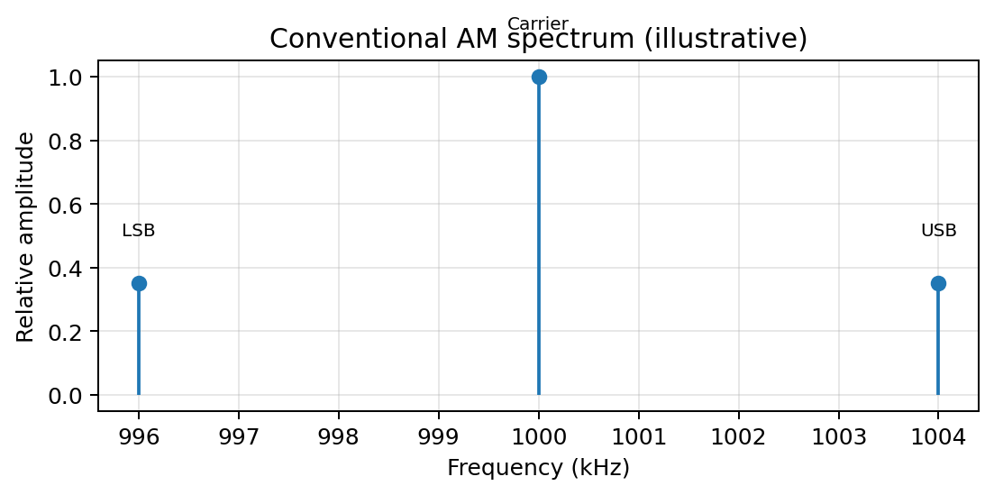
Figure 3. Conventional AM spectrum around a 1 MHz carrier; illustrative line spectrum.
For a 1 MHz carrier and a 4 kHz single-tone message, the carrier is at 1000 kHz, the lower sideband is at 996 kHz, and the upper sideband is at 1004 kHz. For voice containing a range of frequencies up to 4 kHz, the occupied band extends approximately from 996 to 1004 kHz.

2.3 Modulation comparison
Feature | AM | DSB-SC | SSB-SC | VSB-SC
Bandwidth | 8 kHz | 8 kHz | 4 kHz | 4 kHz + vestige
Carrier | Transmitted | Suppressed | Suppressed | Controlled/reduced in typical design
Power efficiency | Lower | Higher than AM | High | High relative to conventional AM
Detection | Envelope | Coherent | Coherent | VSB-compatible filtering/detection
Complexity | Low | Moderate | Higher | Higher
Typical use | Broadcast voice | Carrier-efficient links | Narrowband voice | Analog television

2.4 Quantifying AM power efficiency
For m = 0.7, P_T = 1.245P_c and P_SB = 0.245P_c. The sideband fraction is 0.245/1.245 = 19.68%; the carrier accounts for 80.32%. DSB-SC avoids spending power on a full carrier, while SSB-SC also transmits only one sideband. Exact power comparisons require a common recovered-signal amplitude or link-quality target.

2.5 Why VSB is used for analog television
- Television video can require a wide message bandwidth, so transmitting both full sidebands is expensive in spectrum.
- Ideal SSB filtering over a wide video signal can be difficult, especially near low-frequency components.
- VSB transmits one full sideband and a controlled vestige of the other, giving a practical compromise between bandwidth and filter complexity.

2.6 Generation, detection and synchronization
Scheme | Generation | Detection | Trade-off
AM | Message and carrier combined in an AM modulator | Envelope detector | Simple receiver, lower power efficiency
DSB-SC | Balanced/product modulator | Coherent detector with carrier recovery | Carrier power saved, synchronization required
SSB-SC | Filter or phasing method | Product detector; frequency accuracy matters | Best bandwidth economy, higher complexity
VSB-SC | DSB generation followed by vestigial filter | VSB-compatible filter/detector | Practical wideband compromise

Design Decision 1 – modulation selection
I recommend conventional AM for the primary low-cost educational voice-broadcast prototype because it offers simple envelope detection and low receiver complexity. The 8 kHz bandwidth fits within nominal 20 kHz channel spacing, and m = 0.7 is below overmodulation. Its disadvantage is that only about 19.68% of the calculated total power is in the sidebands for the single-tone case. If spectrum and transmitter-power efficiency become the main priorities and coherent detection is acceptable, SSB-SC is the stronger alternative.

STAGE 3 – RF CHANNEL ALLOCATION AND TRANSMITTER DESIGN
Stage 3 is worth 15 marks. The assignment asks for at least five representative channels, sideband locations, guard-band discussion and labelled transmitter architecture.

3.1 Five-channel allocation example
Channel | Centre (kHz) | AM occupied band (kHz) | Ideal gap to next band
1 | 560 | 556–564 | 12 kHz
2 | 580 | 576–584 | 12 kHz
3 | 600 | 596–604 | 12 kHz
4 | 620 | 616–624 | 12 kHz
5 | 640 | 636–644 | —

This is an illustrative plan on a 20 kHz grid, not a statement of licensed station frequencies. Each conventional AM channel occupies centre ±4 kHz. The ideal gap is 20 − 8 = 12 kHz. Actual allocations must follow the applicable national frequency table and local authorization.

3.2 Selected carrier sidebands
Component | Frequency
Carrier | 1000 kHz
Lower sideband | 996–1000 kHz
Upper sideband | 1000–1004 kHz
Total theoretical AM band | 996–1004 kHz (8 kHz)

3.3 Transmitter architecture
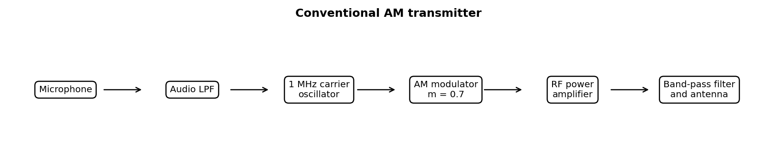
Figure 4. Conventional AM transmitter blocks.
The microphone provides the voice signal. An audio low-pass filter limits the message to 4 kHz. A stable oscillator generates the 1 MHz carrier. The modulator imposes the message with a target modulation index of 0.7. The RF power amplifier raises the output to the design level, and a band-pass filter reduces unwanted emissions before the antenna.

3.4 Generation and detection blocks
Scheme | Transmitter | Receiver
AM | Message + carrier → AM modulator → RF amplifier/filter | RF/IF filter → envelope detector → audio LPF/amplifier
DSB-SC | Message × carrier → balanced modulator → RF filter | RF/IF filter → product detector + recovered carrier
SSB-SC | Balanced modulator → sideband filter or phasing network | RF/IF filter → product detector/BFO → audio LPF
VSB-SC | DSB-type modulator → vestigial-sideband filter | VSB-compatible IF filter and detector

3.5 Guard bands and Design Decision 2
- Keep carrier centres on the assigned 20 kHz grid and check each occupied spectrum.
- Allow for filter transition bands, oscillator drift, distortion products and emission masks.
- Do not treat the theoretical 12 kHz gap as proof of regulatory approval.
Design Decision 2: use a nominal 1 MHz carrier, conventional AM, a 4 kHz audio low-pass limit, a stable carrier source, controlled modulator, RF amplification and output filtering. The nominal 20 kHz grid provides separation for an 8 kHz signal. Confirm actual frequency allocation and permitted radiated power before real transmission.

STAGE 4 – SELECT THE AM RECEIVER ARCHITECTURE
Stage 4 is worth 20 marks. It requires TRF and superheterodyne diagrams, performance comparison, IF choice, image-frequency calculation and detection explanation.

4.1 Receiver block diagrams
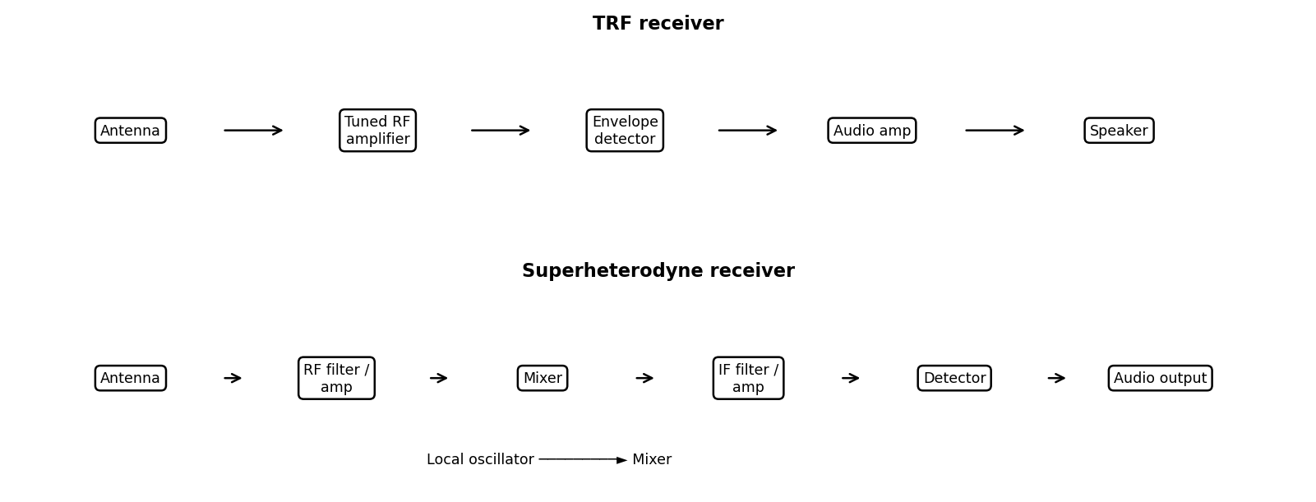
Figure 5. Simplified TRF and superheterodyne receiver diagrams.

4.2 TRF versus superheterodyne
Parameter | TRF | Superheterodyne
Operation | Amplifies selected RF directly | Mixes RF to a fixed intermediate frequency
Sensitivity | Depends on RF-stage gain and tuning | Good controlled gain can be provided at IF
Selectivity | Tuned RF circuits must track together | Fixed IF filter provides stable selectivity
Fidelity | Depends on tuned stages and detector | Good if IF and audio passbands are designed correctly
Stability | Tracking multiple tuned circuits is difficult | LO stability and IF stability are important
Image rejection | No classic mixer image in the same form | Requires RF preselection and suitable IF
Complexity | Simple concept; tuning can be awkward | More stages but practical and widely used

4.3 IF and local oscillator
Choose an illustrative intermediate frequency f_IF = 455 kHz. For f_RF = 1000 kHz and high-side injection, f_LO = f_RF + f_IF = 1000 + 455 = 1455 kHz. The desired mixer difference is |1455 − 1000| = 455 kHz.

4.4 Image frequency
With high-side injection, the image is on the opposite side of the local oscillator from the desired RF: f_image = f_LO + f_IF = 1455 + 455 = 1910 kHz. Equivalently, f_image = f_RF + 2f_IF = 1000 + 910 = 1910 kHz. This lies outside the stated 540–1600 kHz band, although RF preselection is still needed to suppress out-of-band signals and unwanted mixing.
Item | Formula | Result
Desired RF | f_RF | 1000 kHz
Selected IF | f_IF | 455 kHz
High-side LO | f_RF + f_IF | 1455 kHz
Image frequency | f_RF + 2f_IF | 1910 kHz
Desired mixer output | |f_LO − f_RF| | 455 kHz

4.5 Detection methods and Design Decision 3
- Conventional AM: an envelope detector follows the amplitude envelope; its RC time constant must suppress RF ripple without distorting audio.
- DSB-SC/SSB-SC: a product detector uses a local carrier; frequency and phase synchronization matter.
- VSB: filtering and detection must preserve the intended vestigial-sideband response.
Design Decision 3: select a superheterodyne receiver because a fixed IF can provide stable gain and selectivity in a noisy channel. A 455 kHz IF gives a 1.455 MHz high-side local oscillator and a 1.910 MHz image for the 1 MHz desired carrier. Envelope detection is suitable for the selected conventional AM waveform.

STAGE 5 – DEVELOP, VERIFY AND COMPARE THE COMPLETE SYSTEM
Stage 5 is worth 15 marks. It asks for the complete link, spectra, power/bandwidth verification, comparison with a rejected alternative, noise evaluation and prototype suitability.

5.1 End-to-end operation
Voice is limited to 4 kHz, modulated onto a 1 MHz carrier with m = 0.7, amplified and filtered, then transmitted. The superheterodyne receiver selects the signal, converts it to a 455 kHz IF, filters and amplifies it, envelope-detects the message, and applies audio filtering and amplification.

5.2 Verification table
Check | Theoretical result | Interpretation
Message bandwidth | 4 kHz | Matches requirement
AM bandwidth | 8 kHz | Fits nominal 20 kHz spacing
Modulation index | 0.7 (70%) | Below 1; no ideal overmodulation
Carrier power | 10 W | Assignment calculation parameter
Total AM power | 12.45 W | Single-tone calculation
Total sideband power | 2.45 W | 1.225 W per sideband
Selected IF | 455 kHz | Illustrative design choice
Image frequency | 1910 kHz | Outside specified RF band

5.3 Comparison with rejected SSB-SC
AM is selected for simplicity. SSB-SC is not selected for the primary prototype because it needs more complex sideband generation and coherent detection, although it reduces theoretical bandwidth from 8 kHz to 4 kHz. If the design goal changes to maximizing voice-channel capacity or improving power efficiency, SSB-SC should be reconsidered.

5.4 AWGN effects and mitigation
- AWGN adds random disturbance and reduces the signal-to-noise ratio of recovered audio.
- At weak signal levels, noise can disturb the AM envelope and produce audible noise or distortion.
- RF/IF filters reduce out-of-channel interference but cannot remove noise that lies inside the desired passband.
- Adequate gain, stable oscillators, suitable detector time constants and audio-band limiting improve reception.
- Overly narrow filtering removes wanted sideband components, so selectivity must be balanced against fidelity.

5.5 Low-cost implementation and Stage 5 conclusion
A low-cost prototype can use a stable low-power carrier source, audio low-pass filter, AM modulator, properly rated RF stage or dummy-load arrangement, and an AM receiver with IF filtering and envelope detection. MATLAB plots can verify waveforms, spectrum and calculations before hardware implementation. The theoretical checks are consistent, but actual oscillator accuracy, filter response, output power, occupied spectrum and audio quality must be measured.

STAGE 6 – CRITICALLY EVALUATE THE DESIGN AND DEPLOYMENT DECISION
Stage 6 is worth 20 marks. It requires interpretation of waveform and spectrum, AM power verification, scheme comparison, receiver analysis, channel-overlap checks and separate voice/TV suitability.

6.1 Waveform and spectrum interpretation
The selected signal is s(t) = A_c[1 + 0.7 cos(2πf_mt)]cos(2πf_ct). Since m = 0.7 is below 1, the ideal envelope does not cross zero, so envelope detection is appropriate. With f_c = 1 MHz and f_m(max) = 4 kHz, the outer sideband limits are 996 and 1004 kHz.

6.2 Power and bandwidth verification
P_T = P_c(1 + m²/2) = 10(1 + 0.49/2) = 12.45 W. Total sideband power is 2.45 W, split equally into 1.225 W per sideband for a single tone. The AM bandwidth is 8 kHz, and 20 kHz carrier spacing leaves an ideal 12 kHz gap between occupied AM bands.

6.3 Final scheme comparison
Criterion | AM | DSB-SC | SSB-SC | VSB-SC
Bandwidth | 8 kHz | 8 kHz | 4 kHz | 4 kHz + vestige
Power use | Carrier consumes power | Carrier suppressed | Carrier suppressed, one sideband | Efficient sideband use
Receiver | Envelope detector | Coherent detector | Coherent detector | VSB-compatible filtering
Voice broadcast | Simple and practical | Possible, more complex | Good when efficiency dominates | Not usually first choice for narrowband voice
Analog television | Not typical video compromise | Not typical practical choice | Possible but filtering demanding | Well suited to bandwidth/filter compromise

6.4 Receiver performance and channel overlap
Sensitivity and selectivity must be balanced. A narrow IF filter can reject adjacent stations but may distort the 4 kHz voice spectrum if its passband is too narrow. Oscillator drift can move the signal from the IF passband. Image rejection depends on the LO/IF relationship and RF preselection. Since theoretical AM bandwidth is 8 kHz and spacing is 20 kHz, ideal occupied bands do not overlap; real emission skirts and frequency errors must still be verified.

6.5 Voice versus analog-TV suitability
For voice broadcasting, conventional AM is defensible because the receiver is simple and its 8 kHz bandwidth fits the nominal spacing. SSB-SC is preferable if bandwidth and power efficiency dominate and a coherent receiver is acceptable. For analog television, VSB is more appropriate because it reduces bandwidth compared with full DSB while avoiding the demanding ideal sideband suppression of SSB over a wide video signal.

6.6 Risks and improvements
- Verify legal frequency allocation and permitted power before using an antenna.
- Use an output filter and verify occupied bandwidth with suitable instruments or validated simulation.
- Measure modulation index over the expected audio input range and keep it below 1.
- Test receiver audio response across 0–4 kHz and document distortion/noise.
- If efficiency becomes the priority, redesign for SSB-SC; if the application becomes analog TV, evaluate VSB filtering separately.

FINAL ENGINEERING DECISION
DECISION: YES — for a controlled low-power educational prototype, subject to laboratory and regulatory limits.
The proposed conventional AM link meets the theoretical bandwidth requirement: 8 kHz occupied bandwidth for a 4 kHz voice signal fits within nominal 20 kHz channel spacing. With m = 0.7 and P_c = 10 W, ideal single-tone total power is 12.45 W, including 2.45 W in sidebands. A superheterodyne receiver with an illustrative 455 kHz IF and envelope detection balances selectivity, sensitivity and simplicity. The calculated high-side image is 1.910 MHz, outside the specified RF band, although RF preselection remains necessary.
The YES decision applies to the educational design, not automatic permission to radiate 10 W. Before actual deployment, frequency allocation, output power, emissions, antenna use and local rules must be checked. SSB-SC is the recommended redesign if power or spectrum efficiency becomes dominant; VSB remains the more suitable AM-family option for analog-TV transmission.

FINAL SPECIFICATION-VERIFICATION TABLE
Requirement | Target | Design result | Verdict
Message bandwidth | ≤ 4 kHz | Audio path limited to 4 kHz | Meets in design
Carrier | Candidate 1 MHz | 1 MHz selected | Meets
Modulation index | 0.7 | 70% | Meets
AM bandwidth | Fit channel spacing | 8 kHz | Fits 20 kHz grid
Power | P_c = 10 W | P_T = 12.45 W theoretical | Calculated
Channel spacing | 20 kHz | 12 kHz ideal gap between AM bands | No ideal overlap
Receiver | Justified architecture | Superheterodyne, IF 455 kHz | Selected
Image frequency | Calculate and assess | 1.910 MHz | Outside stated band
Detection | Suitable for modulation | Envelope detector | Suitable
Deployment | YES/NO supported | YES for controlled prototype | Conditional

RELEVANT IEEE STANDARDS
[1] IEEE Std 145-2025, IEEE Standard for Definitions of Terms for Antennas. Use this standard for consistent antenna terminology when describing the transmitting and receiving antennas. It is a terminology standard, not an AM modulation or spectrum-allocation specification. Official page: https://standards.ieee.org/ieee/145/7742/
[2] IEEE Std 149-2021, IEEE Recommended Practice for Antenna Measurements. This practice is relevant if the prototype antenna is measured, including radiation-pattern and antenna-test-facility considerations. It supports antenna verification but does not define AM bandwidth, modulation index or permitted transmitter power. Official page: https://standards.ieee.org/ieee/149/6667/
[3] IEEE Std 211-2018, IEEE Standard Definitions of Terms for Radio Wave Propagation. Use it for consistent terminology when discussing propagation, radio waves and the channel. Check the IEEE catalogue before formal compliance claims because a revision project is in progress. Official page: https://standards.ieee.org/ieee/211/6669/

Broadcast-planning references that complement IEEE standards
[4] Recommendation ITU-R BS.560-4, Radio-frequency protection ratios in LF, MF and HF broadcasting. This is relevant to assessing interference protection between broadcast signals; apply the current recommendation together with national rules when evaluating actual channel separation. Official page: https://www.itu.int/rec/R-REC-BS.560
[5] Recommendation ITU-R BS.703, Characteristics of AM sound broadcasting reference receivers for planning purposes. This provides reference-receiver characteristics useful to broadcast planning and receiver-performance discussion. Official page: https://www.itu.int/rec/R-REC-BS.703
[6] Wireless Planning & Coordination (WPC), Government of India. Verify the applicable frequency allocation, licensing and equipment requirements before any over-the-air transmission. This report does not claim that the illustrative channel centres or the 10 W value are licensed.

